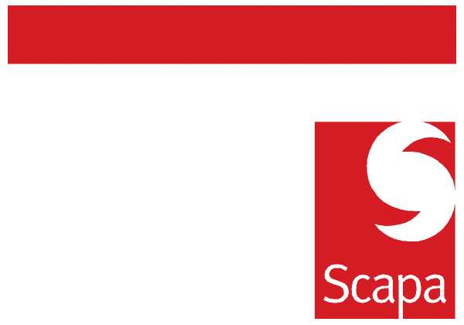

Technical Group Communication
The purpose of this communication is to update you on the Technical Functions within Scapa.
This communication will state the business need from the Technical group, the adaptation of our structure to support that business need and the key process that we will follow to drive product concept to commercialisation.
Group Business Needs
As you have seen from previous Group communication our emphasis is on Cash, Profit and then Growth.
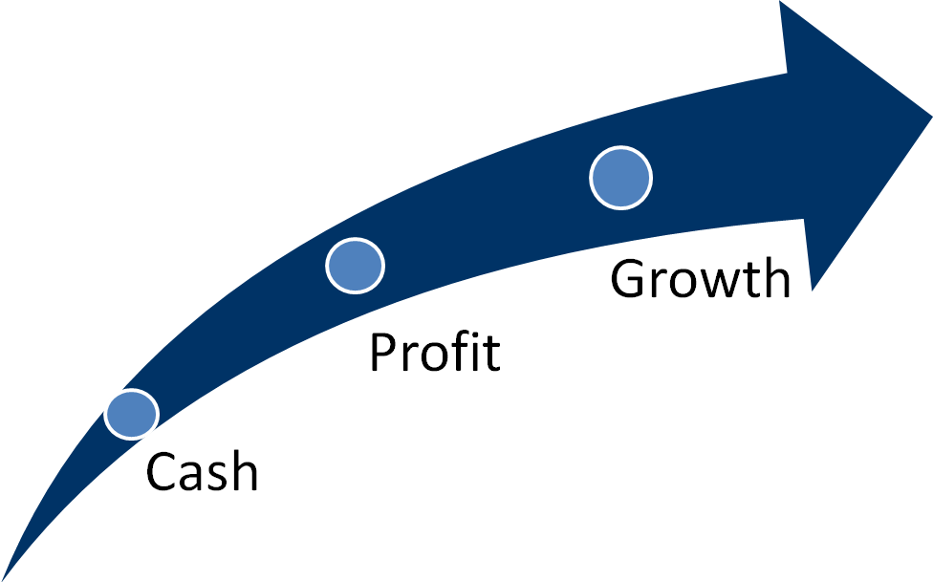
Subsequent Global Technical Priorities for H1 2010/11;
- To improve our Cash delivery we will focus 60% of our resources on taking Cost Out of existing products (called NPV in Europe)
- We will focus 20% of our resources on delivering faster solutions (NPD), quicker than our competitors through customer intimacy/ understanding of value generation and drive improved profitability.
- We will put the other 20% of our resources on to the development of New Products for future (NPD) applications or markets.

Behavioural change and habits of the Technical Group;
- We also believe that it is vital for the success of Scapa that the Technical functions have a strong voice within Scapa and are seen as a true partner in the commercialisation of development.
- Technical leadership must drive a culture of Proactive, Positive Promotion of their function.
Technical Structure;
It is clear that today’s current structure must adapt as the business focus and emphasis changes. For this reason we are looking to align the Technical functions into the 3 groups described below;
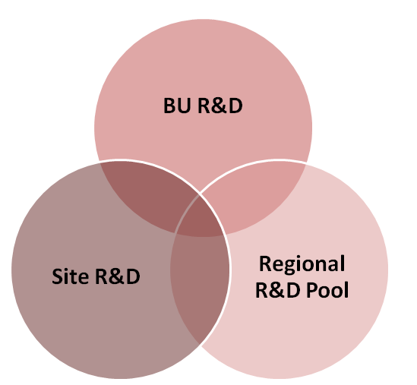
Although there are clear areas of overlap, the distinction in the roles can be aligned to the Group Business Needs and the Global Technical Business priorities;
Group Business Needs | Global Technical Priorities | KEY Functional Group | Metrics | KPI
CASH | Cost Out | R&D Site | GM£ improvement | tbc
PROFIT | Solutions | R&D Business Unit | NPD as a % of revenue | tbc
GROWTH | NPD | R&D Pool | GM£ improvement | tbc

This alignment will mean some minor changes in reporting lines, principle responsibilities and activities.
Confirmation of Metrics and KPI’s will follow in coming weeks.

NPV (Cost Out) and NPD Processes
Today there are processes within Scapa that could at be best described as formalised, however even these have variable levels of compliance and a rigorous GATE process is required to drive necessary disciplines. This will be communicated to you in coming weeks. However for background reading on the subject please use the following website on the Stage-gate process -
The Official Website of the Stage-Gate Product Innovation Process.
http://www.stage-gate.com/video_SG_Innovation.htm
Setting Regional Technical Priorities and Business Case Reviews
In April there will be a review of the existing Cost out (NPV) and NPD Top 10 by Isabelle Rouzeval/IM/BA for Europe and Dan Jeffery/ IM/ MM/ Gene Kim for NA & Asia.
This will then be followed by monthly reviews by this same team to review existing and incoming NPV and NPD Business cases until the process is embedded within the discipline of the BU structure. It is worth noting that from April onwards NO projects will pass through this initial GATE without full compliance and validation of the Business case.

Ian Marchant Mike Muchin Barry Andrew
Global Operations Director Industrial BU VP North America Commercial Director Europe

